**Virtual Mouse (A.I)**

**Project Synopsis**

Project (IAI-851)

**BACHELOR OF TECHNOLOGY (CSE) A.I (i-Nurture)**

|  |  |
| --- | --- |
| PROJECT GUIDE:  **Mr.Sudhanshu Kumar** | SUBMITTED BY:  **Siddharth Singh (TCA1960007)**  **Nirdesh Kumar (TCA1960008)**  **Mohd.Suhel (TCA1960004)**  **Shruti Sharma (TCA1960005)** |

February, 2023



**FACULTY OF ENGINEERING & COMPUTING SCIENCES**

**TEERTHANKER MAHAVEER UNIVERSITY, MORADABAD**

Table of Contents

**1 Project title** 3

**Virtual Mouse (A.I)** 3

**2 Problem Statement** 3

**3 Project Description** 3

**5** **Technologies to be used** 6

**5.1** **Software Platform** 6

**5.2** **Hardware Platform** 6

**5.3** **Tools** 6

**6** **Future Scope and further enhancement of the Project** 7

**7** **Team Details** 7

**8** **Conclusion** 8

**9** **References** 9

## **1 Project title**

## **Virtual Mouse (A.I)**

# **2 Problem Statement**

The proposed AI virtual mouse system can be used to overcome problems in the real world such as situations where there is no space to use a physical mouse and also for the persons who have problems in their hands and are not able to control a physical mouse. Also, amidst of the COVID-19 situation, it is not safe to use the devices by touching them because it may result in a possible situation of spread of the virus by touching the devices, so the proposed AI virtual mouse can be used to overcome these problems since hand gesture and hand Tip detection is used to control the PC mouse functions by using a webcam or a built-in camera.

The main objective of the proposed AI virtual mouse system is to develop an alternative to the regular and traditional mouse system to perform and control the mouse functions, and this can be achieved with the help of a web camera that captures the hand gestures and hand tip and then processes these frames to perform the particular mouse function such as left click, right click, and scrolling function.

# **3 Project Description**

In today’s world we see lots of development happened in the field of Technology. Today’s technology is combined with the technique called Artificial Intelligence. This project is also based on small part of AI. This project presents finger movement gesture detection on our computer’s window using camera & handling the whole system by just moving your one finger.

Using finger detection methods for instant camera access and user-friendly user interface makes it more easily accessible. The system is used to implement motion tracking mouse, a signature input device and an application selector. This system reduces the use of any physical mouse which saves time and also reduces effort.

With the development technologies in the areas of augmented reality and devices that we use in our daily life, these devices are becoming compact in the form of Bluetooth or wireless technologies. This paper proposes an AI virtual mouse system that makes use of the hand gestures and hand tip detection for performing mouse functions in the computer using computer vision. The main objective of the proposed system is to perform computer mouse cursor functions and scroll function using a web camera or a built-in camera in the computer instead of using a traditional mouse device. Hand gesture and hand tip detection by using computer vision is used as a HCI [1] with the computer. With the use of the AI virtual mouse system, we can track the fingertip of the hand gesture by using a built-in camera or web camera and perform the mouse cursor operations and scrolling function and also move the cursor with it.

While using a wireless or a Bluetooth mouse, some devices such as the mouse, the dongle to connect to the PC, and also, a battery to power the mouse to operate are used, but in this paper, the user uses his/her built-in camera or a webcam and uses his/her hand gestures to control the computer mouse operations. In the proposed system, the web camera captures and then processes the frames that have been captured and then recognizes the various hand gestures and hand tip gestures and then performs the particular mouse function.

Python programming language is used for developing the AI virtual mouse system, and also, OpenCV which is the library for computer vision is used in the AI virtual mouse system. In the proposed AI virtual mouse system, the model makes use of the MediaPipe package for the tracking of the hands and for tracking of the tip of the hands, and also, Pynput, Autopy, and PyAutoGUI packages were used for moving around the window screen of the computer for performing functions such as left click, right click, and scrolling functions. The results of the proposed model showed very high accuracy level, and the proposed model can work very well in real-world application with the use of a CPU without the use of a GPU.

**4 Implementation Methodology**

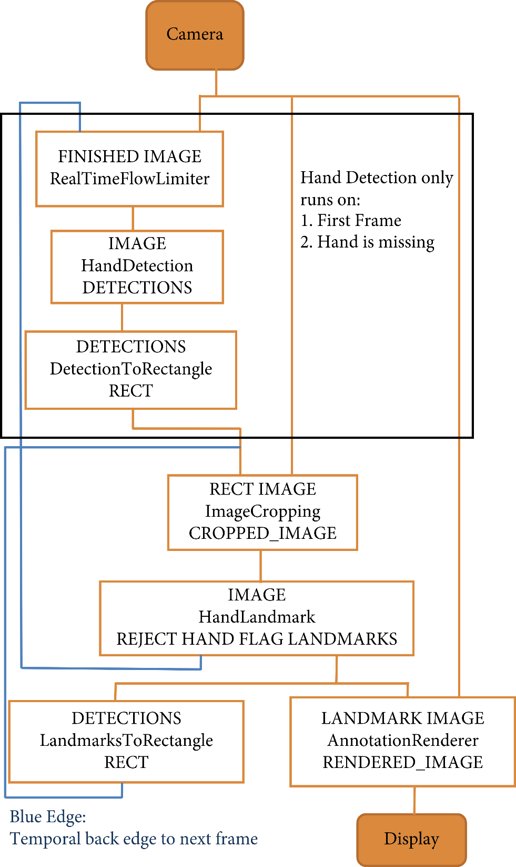

# **Technologies to be used**

## **Software Platform**

Python Version - 3.11.2.

Anaconda 3 (I.D.E).

Visual Code – 1.77.3.

Operating System Windows (7,8,10,11)

## **Hardware Platform**

RAM - Minimum 4gb.

Hard Disk - Minimum 32gb.

Processor i-3, AMD 3 upwards.

## **Tools**

Technical Process Following would be the languages I would use to develop my application within the stipulated period:

1) Media Pipe.

2) Open – CV.

3) Math.

4) Pyautogui.

5) Intenum.

6) Message to dict.

# **Future Scope and further enhancement of the Project**

The proposed AI virtual mouse has some limitations such as small decrease in accuracy of the right click mouse function and also the model has some difficulties in executing clicking and dragging to select the text. These are some of the limitations of the proposed AI virtual mouse system, and these limitations will be overcome in our future work.

Furthermore, the proposed method can be developed to handle the keyboard functionalities along with the mouse functionalities virtually which is another future scope of Human-Computer Interaction (HCI).

# **Team Details**

|  |  |  |  |  |  |
| --- | --- | --- | --- | --- | --- |
| **Project Name** | **Course Name** | **Student ID** | **Student Name** | **Role** | **Signature** |
| **Virtual Mouse (A.I)** | **Project** | TCA1960007 | Siddharth Singh | Implementation. |  |
| TCA1960008 | Nirdesh Kumar | Idea, Testing. |  |
| TCA1960004 | Mohd.Suhel | Documentation. |  |
| TCA1960005 | Shruti Sharma | Error Handling. |  |

# **Conclusion**

The main objective of the AI virtual mouse system is to control the mouse cursor functions by using the hand gestures instead of using a physical mouse. The proposed system can be achieved by using a webcam or a built-in camera which detects the hand gestures and hand tip and processes these frames to perform the particular mouse functions.

From the results of the model, we can come to a conclusion that the proposed AI virtual mouse system has performed very well and has a greater accuracy compared to the existing models and also the model overcomes most of the limitations of the existing systems. Since the proposed model has greater accuracy, the AI virtual mouse can be used for real-world applications, and also, it can be used to reduce the spread of COVID-19, since the proposed mouse system can be used virtually using hand gestures without using the traditional physical mouse.

The model has some limitations such as small decrease in accuracy in right click mouse function and some difficulties in clicking and dragging to select the text. Hence, we will work next to overcome these limitations by improving the finger tip detection algorithm to produce more accurate results.

# **References**

Zhang, Jiajun, and Chengqing Zong. "Deep Neural Networks in Machine Translation: An Overview." *IEEE Intell. Syst.* 30.5 (2015): 16-25.

Khan, Nabeel Sabir, Adnan Abid, and Kamran Abid. "A novel natural language processing (NLP)–based machine translation model for English to Pakistan sign language translation." *Cognitive Computation* 12 (2020): 748-765.

Nakazawa, Toshiaki, Kun Yu, Daisuke Kawahara, and Sadao Kurohashi. "Example-based machine translation based on deeper NLP." In *Proceedings of the Third International Workshop on Spoken Language Translation: Evaluation Campaign*. 2006.

Rishita, Middi Venkata Sai, Middi Appala Raju, and Tanvir Ahmed Harris. "Machine translation using natural language processing." In *MATEC Web of Conferences*, vol. 277, p. 02004. EDP Sciences, 2019.

Orife, Iroro, Julia Kreutzer, Blessing Sibanda, Daniel Whitenack, Kathleen Siminyu, Laura Martinus, Jamiil Toure Ali et al. "Masakhane--Machine Translation For Africa." *arXiv preprint arXiv:2003.11529* (2020).

Mitkov, R., 1999. Introduction: special issue on anaphora resolution in machine translation and multilingual NLP. *Machine translation*, pp.159-161.